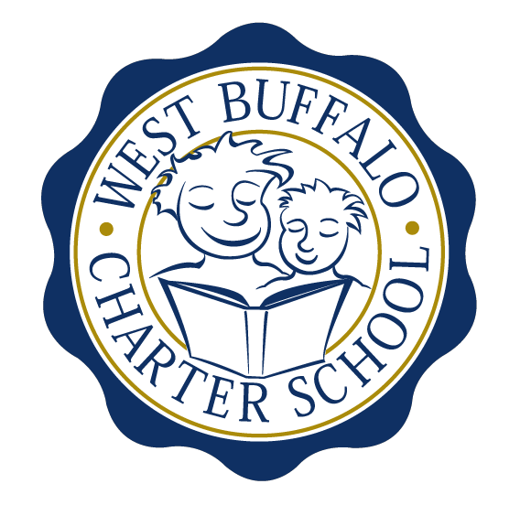

West Buffalo Charter School

Board of Trustees Meeting
April 24, 2017
2:30 PM
D’Youville College, Buffalo, New York

Board Members
Present: Arup Sen, Michelle Stevens, James Deuschle, Richard Baer, Lee Pearce, Amy Friedman
Excused: James Sampson, Lynn Shea
Also Present: Liz Sterns, Andrea Todoro
Quorum Present: Yes

Call to Order
Dr. Sen called the meeting to order at 2:34 PM. Quorum present.

Proof of Public Notice of Meeting
Media and public announcement was sent on Tuesday, April 18th, 2017 to print, radio, and TV outlets announcing this open meeting. A posting was also sent to Erie County Hall, Buffalo City Hall and Buffalo City Court. In addition, it was publicly displayed at 50 East North Street and posted on the WBCS website. The Board of Trustees was duly notified of this meeting well within the timeline of our bylaws.

Monthly Meeting

Review of the March 27th, 2017 Meeting Minutes
Minutes of the March 27th, 2017 Board of Trustees meeting were presented for approval.

Upon motion duly made by Mrs. Stevens and seconded by Mr. Baer, the minutes of the March, 2017 board meeting were approved as presented. All in favor. Non-opposed.

Expansion Plan
- Phase IV almost complete. Some minor details to be completed.
- Phase V plans submitted.
- Mr. Deuschle made the suggestion that the Finance Committee meet in the first week of May then call for a special meeting either by phone conference or electronically to confer with all other board members.
- Mrs. Pearce presented information pertaining to PR and Marketing in regards to the new building.
- Tours of the new building for families utilizing students from the older grades first week of June. Inviting the media to attend.

Financial Report
Mrs. Sterns presented the financial reports for the period ending March 31st, 2017 (a copy is attached hereto and made a part hereof).

Upon motion duly made by Mr. Baer and seconded by Mrs. Stevens, the March 31st, 2017 financial statements were approved as presented. All in favor. Non-opposed.

School Leader Report
Mrs. Todoro presented the School Leader report (a copy is attached hereto and made a part hereof).

- Dr. Sen requested Mrs. Todoro to check the by-laws language pertaining to new hires.
- Mrs. Todoro presented the 2017-2018 Math Curriculum Plan.
- A Health and Wellness class will be presented to the 5th grade boys and girls by the school Nurse. The focus of attention will be on hygiene and general wellness as opposed to “sex ed.”

New Business
- Mrs. Pearce reported on the PR and Marketing Committee meeting held on Wednesday, April 19th.
- Dr. Sen referenced Ms. Haefner’s resignation from the WBCS board.
- Mrs. Stevens has a potential board candidate in the health/medical field that would fill the vacancy board seat.
- Mrs. Friedman has made contact with Diane Bessel from Daemen College regarding a board retreat (half day meeting). The idea was suggested that perhaps the July board meeting and the board retreat occur on the same day with lunch provided by D’Youville College.

Upon motion duly made by Mrs. Friedman and seconded by Mrs. Stevens, the board agreed to use Diane Bessel from Daemen College to facilitate the board retreat early this summer. All in favor. Non-opposed.

Adjournment
Being that there is no further business to discuss, a motion to dismiss was made by Mrs. Stevens and seconded by Mrs. Friedman. The meeting was adjourned 4:03 PM.

Respectfully submitted,
Leslie Bunis Ohl

The next WBCS board meeting will take place on Monday, May 22nd, 2:30PM at D’Youville College, Bauer Family Academic Center, Room 105.

